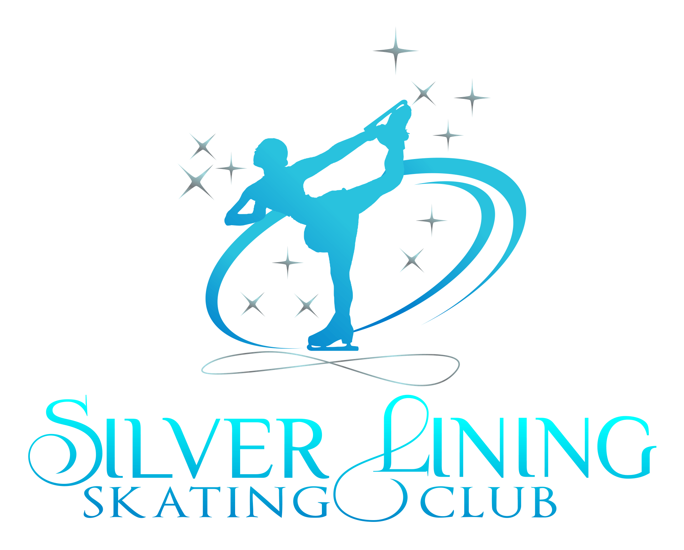
Approved Coaches Requirements Form
Requirements must be met in order to become an approved Silver Lining Club coach. Approved coaches are exempt from $5-/hr freestyle fee, and are added to list for those new skaters interested in private lessons. Club Coaches will be required to attend a MANDATORY meeting (at a location or via Zoom) once every 3 to 4 months. Please retain this form and fill out properly, when completed turn in for review.
Name:___________________________________________________________
Emaik:___________________________________________________________
Phone:__________________________________________________________
ISI Pro #:____________________________PSA #:________________________
- Must be registered with ISI, as a professional representing Silver Lining Skating Club.
- Must sign and return Coaches Code of Conduct.
- Must have Liability Insurance through PSA, yearly.
- Must Have completed PSA CER’s, yearly.
- Must Volunteer at least one show or club event.
Event & Date:_________________________________________________________
- Must volunteer and complete coaching 3(Three) full 8 week Learn to Skate/Tots Session.
Session Dates:_________________________________________________________
::::OR::::
Must have 4 skaters contract a freestyle session each month, in the event we do not have a class for you.
Skaters Names:_______________________________________________________
- Must volunteer to judge 3 times at competitions, in addition to what is required of coaches at each competition.
Competition/Date:______________________________________________________
Competition/Date:______________________________________________________
Competition/Date:______________________________________________________
Please provide copy of:
- Liability Insurance
- Completion of PSA CER’s
- Background Check Approval through ISI.
- ISI Membership
- PSA Membership
If you have, please provide as well:
- USFSA SafeSport completion
- USFSA Membership/Green Light

