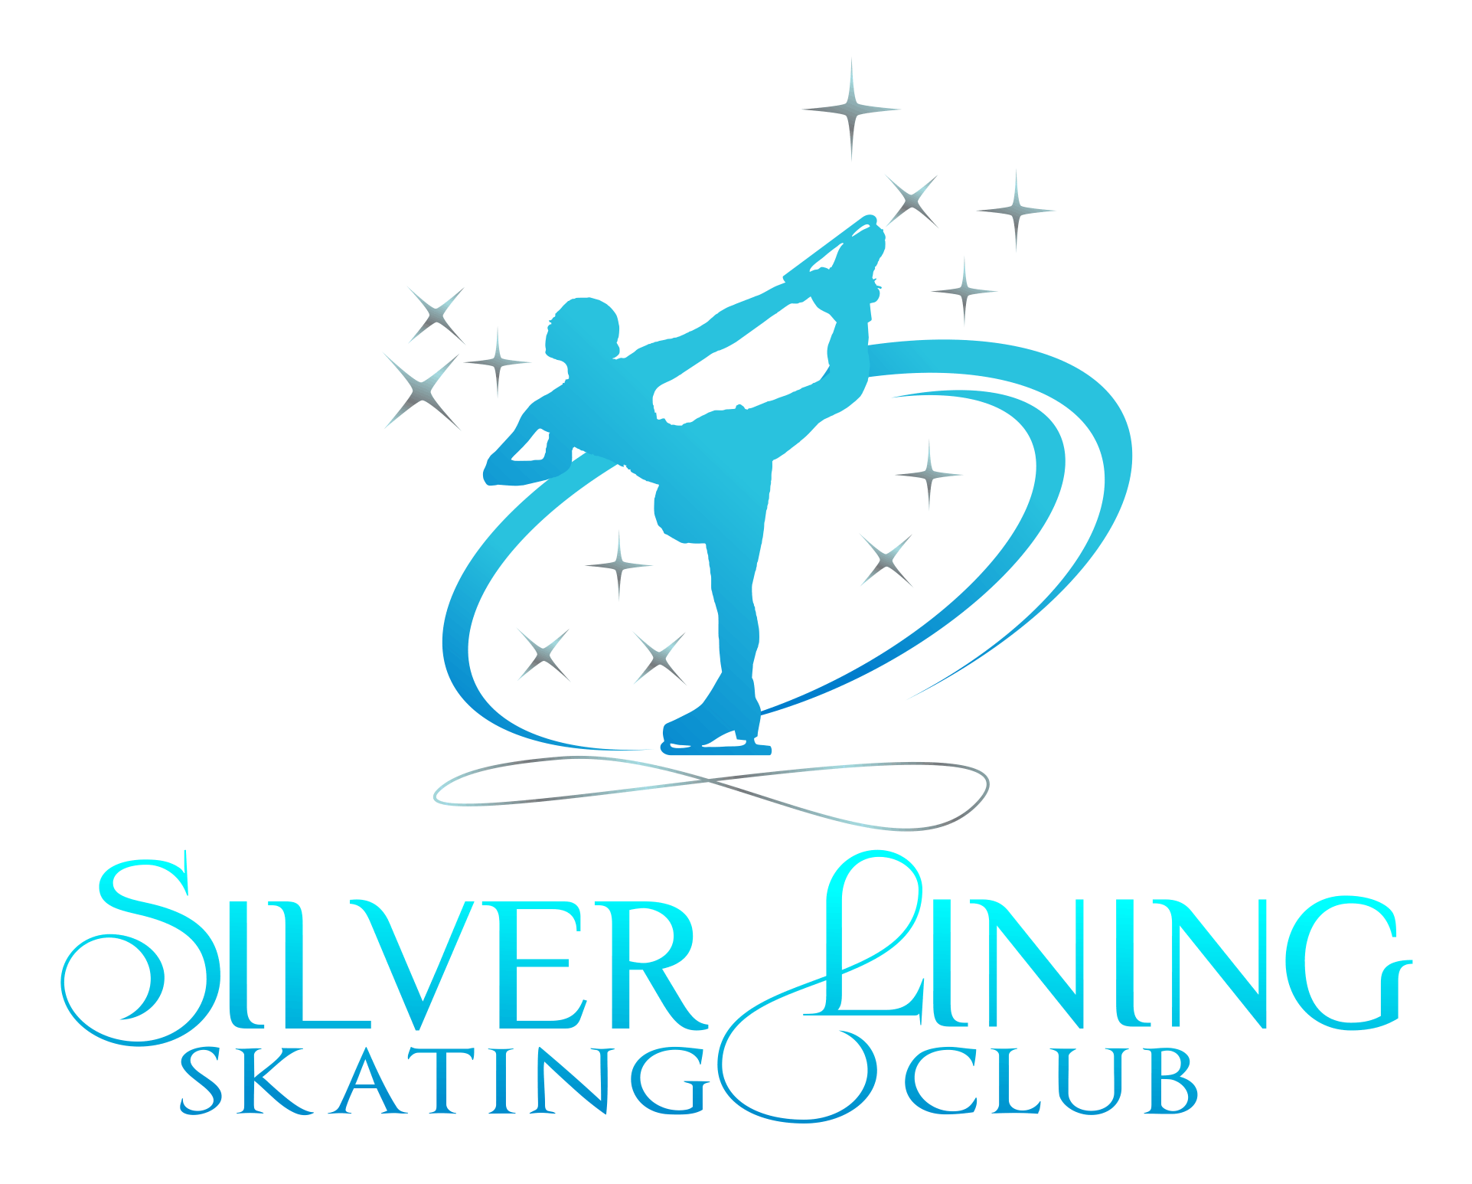
SKATERS CODE OF CONDUCT- TERM 2020-2021
Silver Lining Skating Club is committed to creating a safe and positive environment for members’ physical, emotional and social development and ensuring that it promotes an environment free of misconduct of any kind. This Skaters Code of Conduct has been established to ensure the safety of all members using our ice to ensure quality practice time for all home club, associate, non-members and guests who purchase ice from the club and who participate in all club-related activities.
All skaters, regardless of whether they hold home club, or non-member status, must follow and uphold the provisions in this Skater Code of Conduct regarding behavior on and off the ice.
ON AND OFF THE ICE
- All club members are expected to exhibit good sportsmanship and be courteous toward their fellow skaters, coaches, board members, parents/guardians of skaters, officials and guests AT ALL TIMES.
- SLSC is committed to promoting a positive, safe and friendly environment for all skaters and club members.
- Bullying (including cyberbullying), intimidation, threats and harassment will NOT be tolerated in any way.
- Any skater who violates the Skater Code of Conduct, may be suspended or removed from the club.
ICE ETIQUETTE AND SAFETY-
The Coaches/Pro's have full authority in monitoring and disciplining skaters regarding on ice behaviors and skating etiquette.
- While in lesson or practice, it is the skater’s responsibility to always be conscientious and aware of other skaters around them.
- Skaters must skate with the flow of other skaters and familiarize themselves with the most commonly used areas for jumps and spins.
- Keep skating at all times. DO NOT slow down and DO NOT stand in the middle of the ice. DO NOT skate without looking in the direction you are going.
- DO NOT talk unnecessarily to other skaters while on the ice. DO NOT stand by the boards. It’s distracting to both skaters and pros. Keep moving or get off the ice.
- Show respect for the sport at all times. Treat all skaters, pros, and ice monitors with respect. Bad language and inappropriate behavior will NOT be tolerated, and will result in being asked to leave the ice.
- Get up quickly if you fall. Laying on the ice is extremely dangerous to you as well as other skaters. This is Skating not Swimming.
- The only time a skater has the SOLE right of way is when they are skating their program to music. When you hear another member’s music, please be aware and courteous of who is skating and move out of their path momentarily. This only takes a moment and you will enjoy the same courtesy while you are performing your program. Skaters skating their program MUST wear a scarf around their waist to help others know whos music is playing.
- Advanced skaters are expected to exhibit patience toward beginner members of the club. Remember you were once an inexperienced skater as well, and it takes time for our future generation to advance to the point where they are completely comfortable skating with all levels of skaters.
UNSAFE OR DISCOURTEOUS BEHAVIOR
Unsafe or discourteous behavior of any kind (on ice or off, anytime representing SILVER LINING SKATING CLUB and /or DURING USE OF CLUB ICE) will not be tolerated and could result in removal from ice and/or suspension or termination from the club and freestyle ice usage . Coaches have full authority in monitoring and reporting inappropriate behavior.
Skaters are expected to be polite and show respect for fellow skaters as well as coaches, parents, and others involved in any competitions, shows and testing. Reasonable manners and behavior are expected both on and off the ice, at all times.
If coaches have a problem with a skater acting inappropriately during practice or displaying other negative behavior, the coach has the right to ask the skater to leave the ice and sit within view of the coach. Multiple occurrences of the same behavior can lead to suspension or termination of membership and/or ice use.
Inappropriate behavior includes, but is not limited to, the following actions and behaviors :
- Extreme displays of anger, kicking, hitting, punching boards, ice or others.
- Swearing or discourteous language used toward the coach, skaters or parents.
- Destruction or theft of rink or locker room property.
- Intentioal and repeated distraction of other skaters.
- Disruption of others during lessons.
- Speaking negatively about another skater or coach during practice or competition/testing.
- Hitting other skaters, bullying, hazing.
- Actions that put other skaters at risk of injury
- Not leaving the ice when asked to allow for Zamboni.
- Unsportsmanlike conduct or disrespectful behavior toward coaches or others in both rink and locker room..
I have closely read the Code of Conduct and hereby acknowledge my willingness to observe it. I realize the Code of Conduct will be in effect during my entire figure skating career.
Skaters Signature:______________________________________________Date:___________________
I have read the Code of Conduct and consent to have my son/daughter participate in the club events under these rules and regulations.
Parent/Guardian Signature:_____________________________________ Date: ____________________

