hALLOWEEN SHOW REGISTRATION FORM
registration fee $50- all additional numbers $10/each
All payments and forms due by September 30th. Cash or check only.

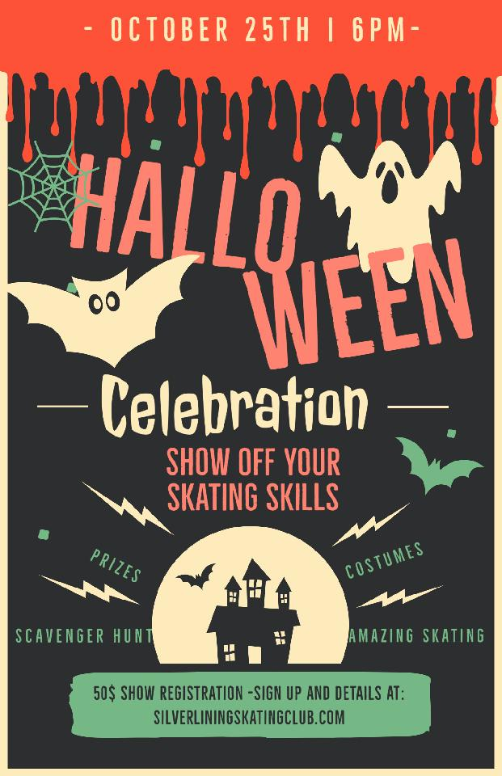

SKATER NAME: ___________________________________________________
Music title (if skating a solo):
_________________________________________________________________
Group Numbers (please list numbers you are skating in):
_________________________________________________________________
_________________________________________________________________
_________________________________________________________________

Total amount due:___________________________
PARENT/GUARDIAN NAME: ________________________________________
PARENT/GUARDIAN CONTACT #: ___________________________________

